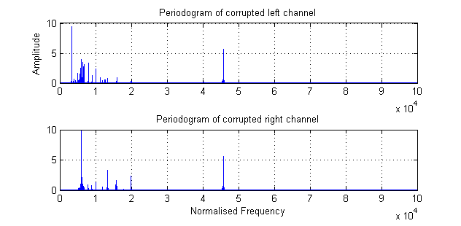**5. A Real World Case Study: Vinyl Denoising**

**5.1**

**Figure 1.** Periodograms of corrupted music

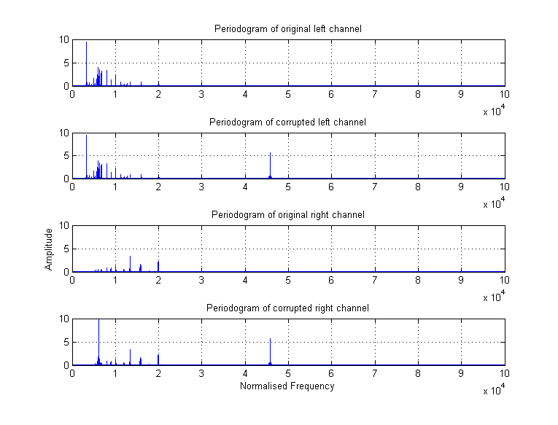Figure 1 shows the corrupted periodograms of both channels. It is observed that there is one single peak at around 0.03 radians/second, corresponding to around 1500 Hz. From spectrum it seems that this peak is out of normal music frequency band, but it is still possible in some music to have this high frequency sound throughout the song. As a result, it is difficult to identify the noise peak without any comparison in this case.

**5.2**

**Figure 2.** Periodograms of corrupted and uncorrupted music

Figure 1 shows the periodograms of original and corrupted music in both channels. It is obvious to identify noise spectrum in this case. For left channel, the noise is at 0.03 radians/second. While for right channel, noise peaks are at 0.002 and 0.03 radians/second. Comparing the corrupted and original data provide us with information about noise peaks.

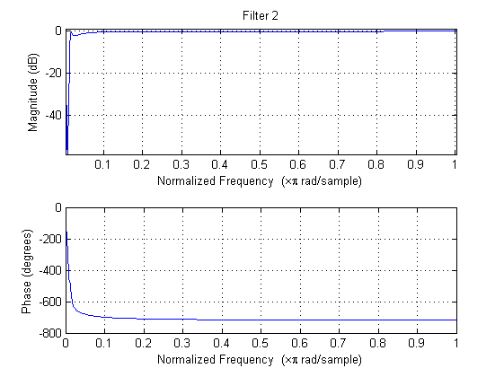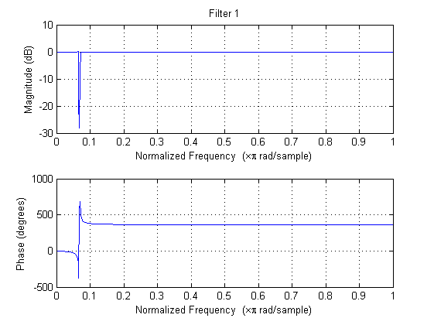**5.3**

**Figure 3.** (Left) First filter response, (right) Second filter response

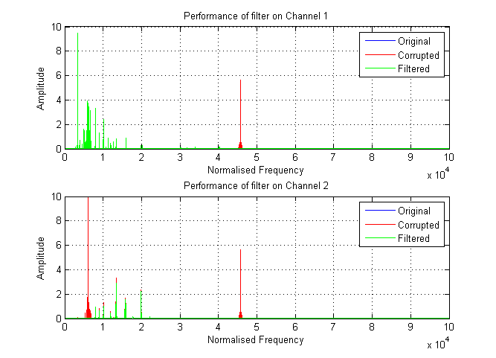Figure 3 shows the filter design to remove the noise peak identified in different frequencies. In this section, I choose Chebyshev filter, which has sharp transition band in order to maximise the music quality. From corrupted music, we figure out that the noise peak is at 206.6 Hz and 1500 Hz. A band-stop filter is designed to attenuate the signal at that small frequency region. Normalised frequencies are then passed to the cheby1 function. Order number are chosen to be 10 and 6 correspondingly, and stop-band ripple are set to a reasonably small number such as 0.1. Note that filter 2 is only designed to remove the noise at low frequency, which does not exist in left channel. As a result, channel 1 only requires to pass the first filter.

**5.4**

**Figure 4.** (Top) Channel 1 noise removal, (Bottom) Channel 2 noise removal

Figure 4 shows the effect of filter on both channels. It is obvious that the noise bins at stated frequencies are attenuated. Most original music nodes are kept after filtering. Also, in the listening test, tick noise are completely removed and not noticeable by listener.

Quantitatively, using the formula , we obtain the difference between filtered signal and original signal. Smaller result means more signals are remained after filtering. However, it does not mean noise removal is better, since sometimes noise removal will sacrifice some music quality. In this experiment, the quantitative performance measure for channel 1 and 2 are 0.0072 and 0.24 correspondingly. Some frequency bins in channel 2 are attenuated in low frequency part in order to remove the low frequency noise completely.

**5.5**

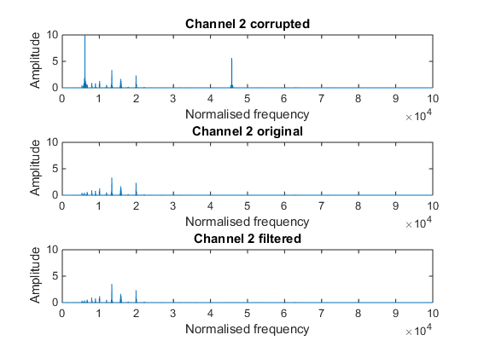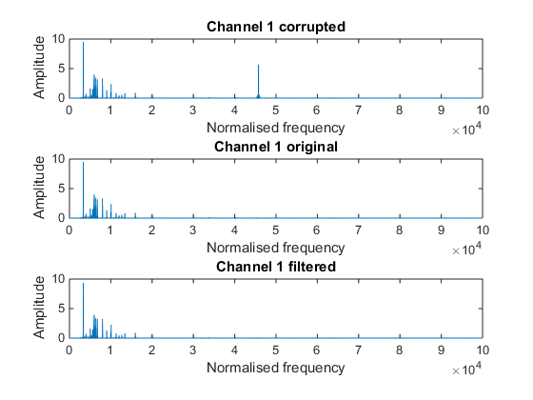

**Figure 5.** (Left) Channel 1 noise removal, (Right) Channel 2 noise removal for s2h

Figure 5 shows the nosie subtraction effect on both channels, it is obvious that noise peaks are significantly attenuated. Different parameter settings lead to different filtered result. Adaptation gain determines how fast coefficients react. Since this is a non-stationary case, reasonably higher adaptation gain will lead to better filter coefficients. But when adaptation gain is too large, inaccurate coefficients may be generated. Also, higher filter order increase the noise subtraction result at the cost of complexity.

Using quantitative performance measure we calcuated the values when order is set to 19. The value for channel 1 is 0.03 and for channel 2 is 0.054.

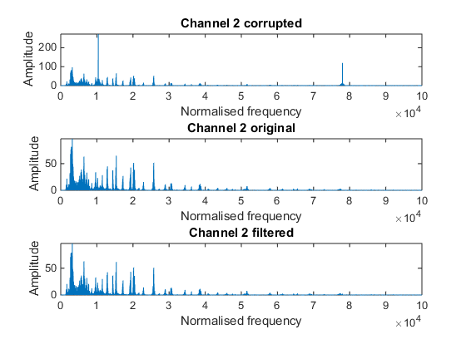**5.6**

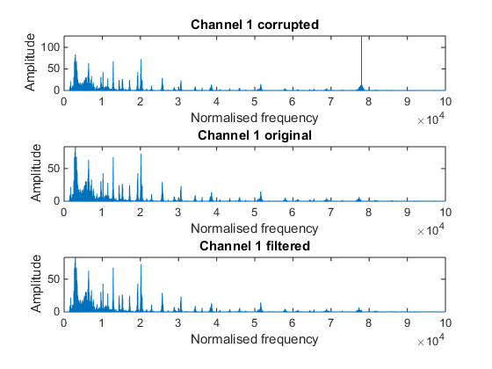

**Figure 5.** (Left) Channel 1 noise removal, (Right) Channel 2 noise removal for um

Figure 6 shows the noise removal performed on the second musical track. The change on periodogram shows clearly that noise peak is attenuated. Quanlitively, the sound removal effect is much better than the first track, this is because the noise peak is large, so that it is easy to be tracked my adaptive filter. Quantitatively, the performance measure for channel 1 and channel 2 are 0.01 and 0.07 correspondingly, which shows better nosie removal effect.